**Assignment no 3**

Muhammad Sami Rizwan

Section B

**1. How to duplicate repeating items inside a Dart list?**

**Problem**

**Consider the code:**

**final List<Ball> _ballList = [Ball (), Ball (), Ball (), Ball (), Ball (),]**

**What can to be done in order to not repeat Ball () multiple times?**

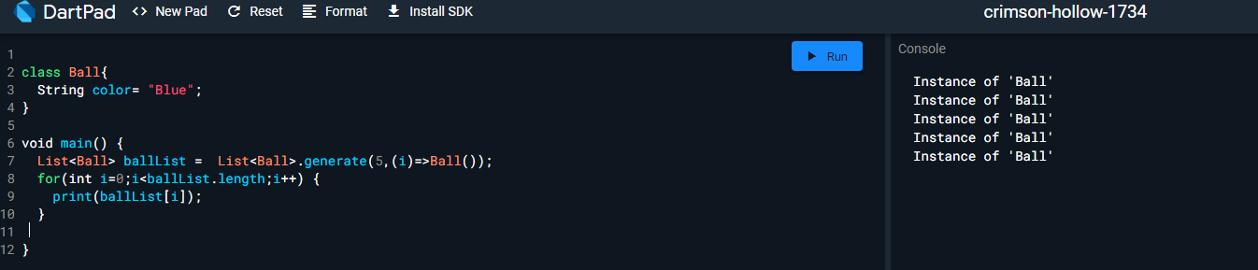

**2. How to get difference of lists in Flutter/Dart?**

**Problem**

**Consider you have two lists [1,2,3,4,5,6,7] and [3,5,6,7,9,10]. How**

**would you get the difference as output? eg. [1, 2, 4]**

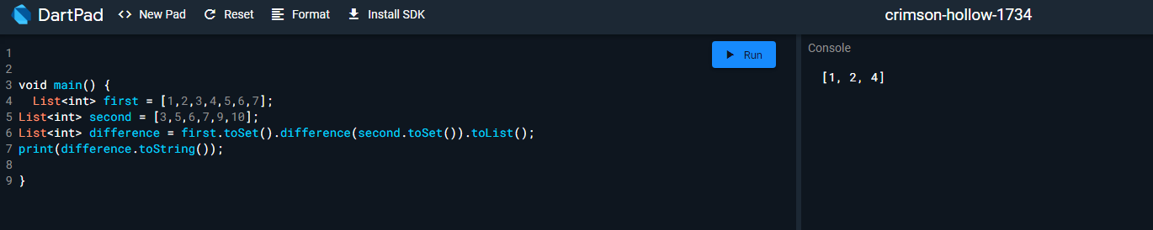

**3. Let’s say you are given a list saved in a variable:**

**Consider a = [1, 4, 9, 16, 25, 36, 49, 64, 81, 100].**

**Write a code that takes this list and makes a new list that has only the**

**even elements of this list in it.**

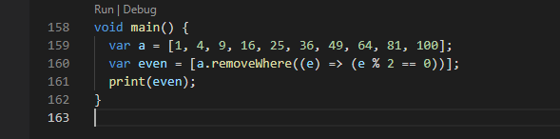

**4. Ask the user for a number and determine whether the number is**

**prime or not.s**

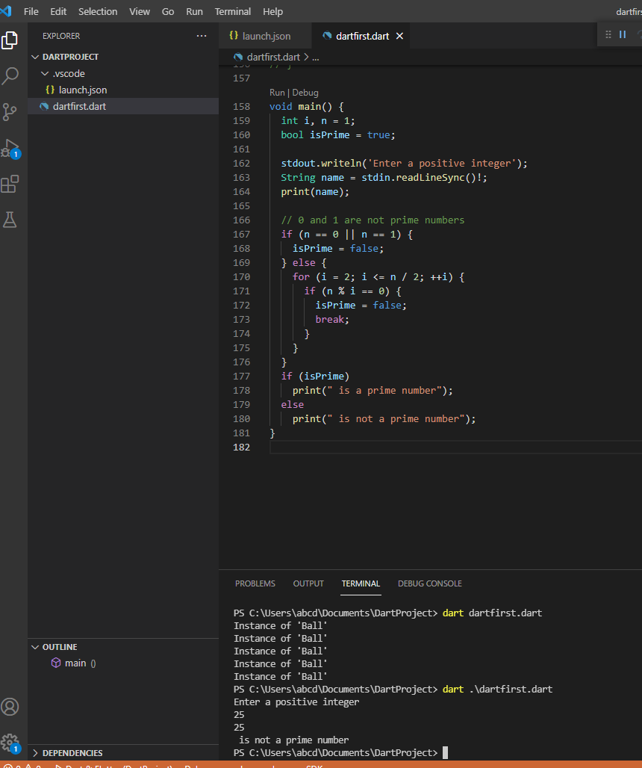

**5. Write a program to print multiplication table of 7 length 15.**

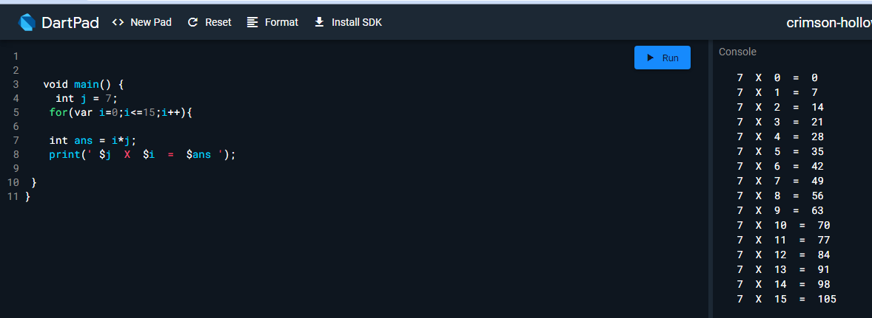

**6. Write a program to print items of the following array using for loop:**

**fruits = [“apple”, “banana”, “mango”, “orange” , “strawberry”].**

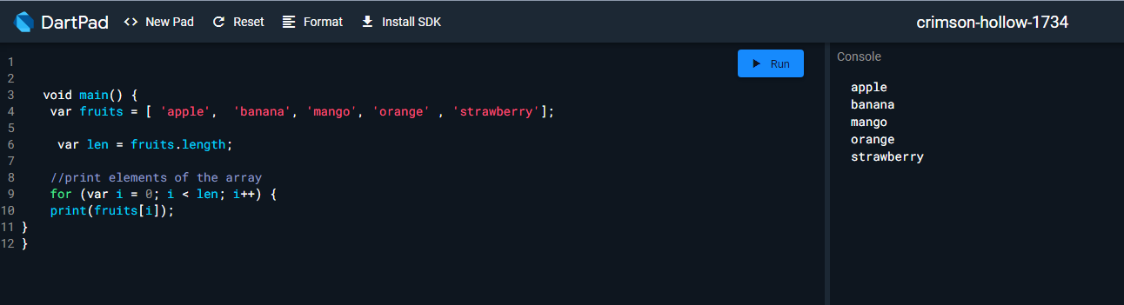

**7. Write a program to print multiples of 5 ranging 1 to 100.**

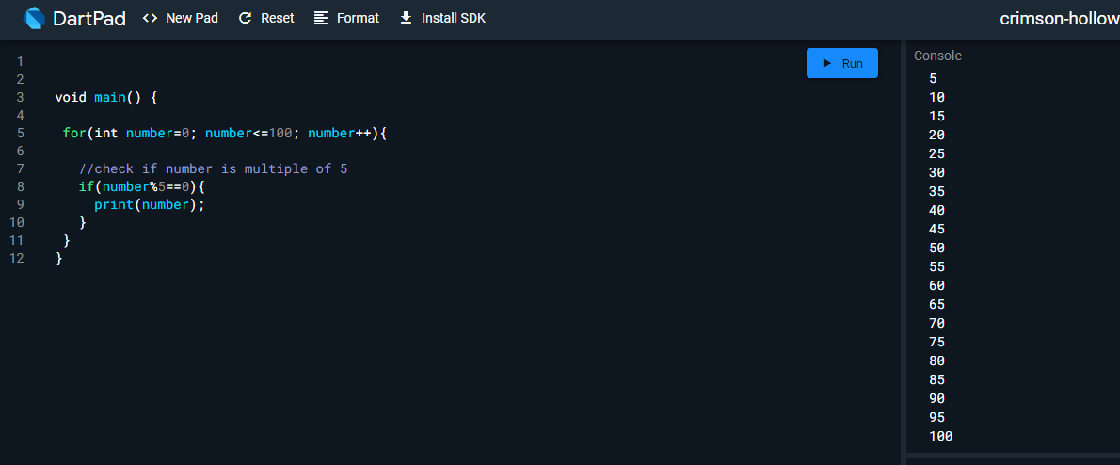

**9. Write a program to create a calculator for +, -, *, / & % using if**

**statements. Take the following input:**

**a. First number Second number**

**b. Operation (+, -, *, /, %)**

**Compute & show the calculated result to user.**

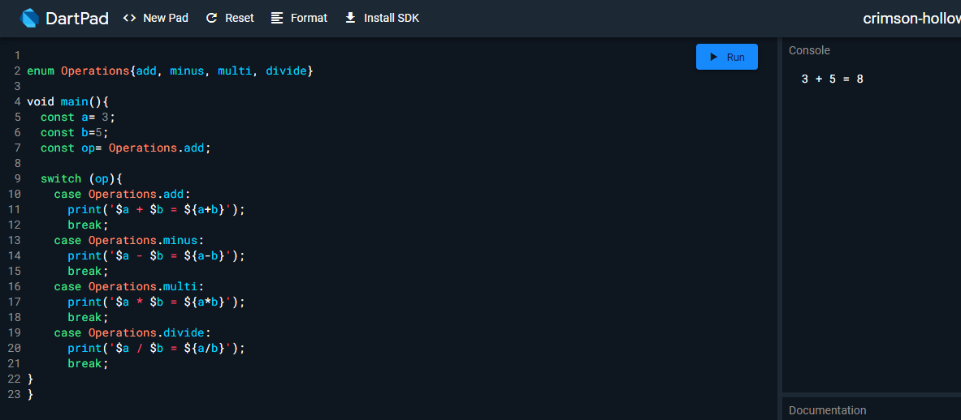

**10. Write a program that takes a character (I. e. string of length 1)**

**and returns true if it is a vowel, false otherwise.**

